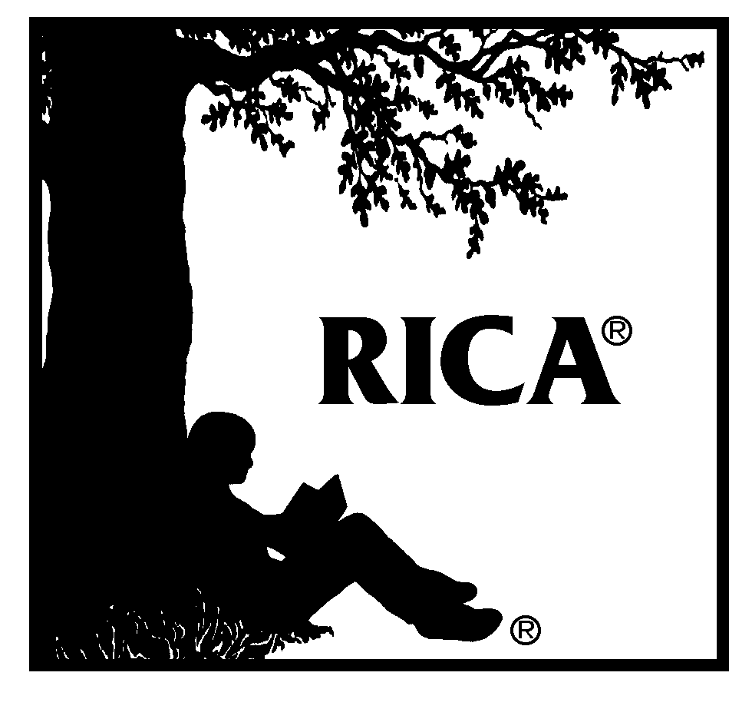 | Commission on Teacher Credentialing  Reading Instruction Competence Assessment®  Video Performance Assessment  PARENT/GUARDIAN/FAMILY CONSENT FORM

Dear Parent/Guardian/Family:

California legislation requires that new teachers pass an assessment of reading instruction before obtaining a teaching credential. The Reading Instruction Competence Assessment® (RICA®) was developed by the Commission on Teacher Credentialing (CTC) in response to this legislation.

One component of this reading assessment is the RICA Video Performance Assessment, a video-based assessment of reading instruction. This assessment involves video-recording teachers (including teacher candidates) as they provide reading instruction to students in their classrooms. No evaluations of students will be made from the video recordings. The video recordings will be used only for the evaluation of teacher performance, research, and the development and implementation of a teacher assessment program.

Your child's teacher (or teacher candidate) has registered for the RICA Video Performance Assessment and would like your permission to have your child participate in the video-recorded lessons. These lessons will be designed by your child's teacher as part of the regular reading curriculum. Please complete the permission form below, indicating whether or not your child may participate in this video-recording. This form must be returned to your child's teacher by _______________________ (insert date). Children for whom permission is not obtained will not be asked to participate.

Copyright © 2021 Pearson Education, Inc. or its affiliate(s). All rights reserved.
Evaluation Systems, Pearson, 300 Venture Way, Hadley, MA 01035
RICA, Reading Instruction Competence Assessment, and the RICA logo are trademarks of the
Commission on Teacher Credentialing and Pearson Education, Inc. or its affiliate(s).
Pearson and its logo are trademarks, in the U.S. and/or other countries, of Pearson Education, Inc. or its affiliate(s).

Reading Instruction Competence Assessment® (RICA®)

Parent/Guardian/Family Consent

q I give permission q I do not give permission (check one box)
for ______________________________________________________________ (insert teacher's name)
to video-record ______________________________________________________ (insert child's name) during classroom reading instruction and to the Commission on Teacher Credentialing and the Evaluation Systems group of Pearson to use the resulting video recordings without identification of my child for the evaluation of teacher performance, research, and the development and implementation of a teacher assessment program.

_________________________________________ ____________________________
Parent/Guardian/Family Signature Date

