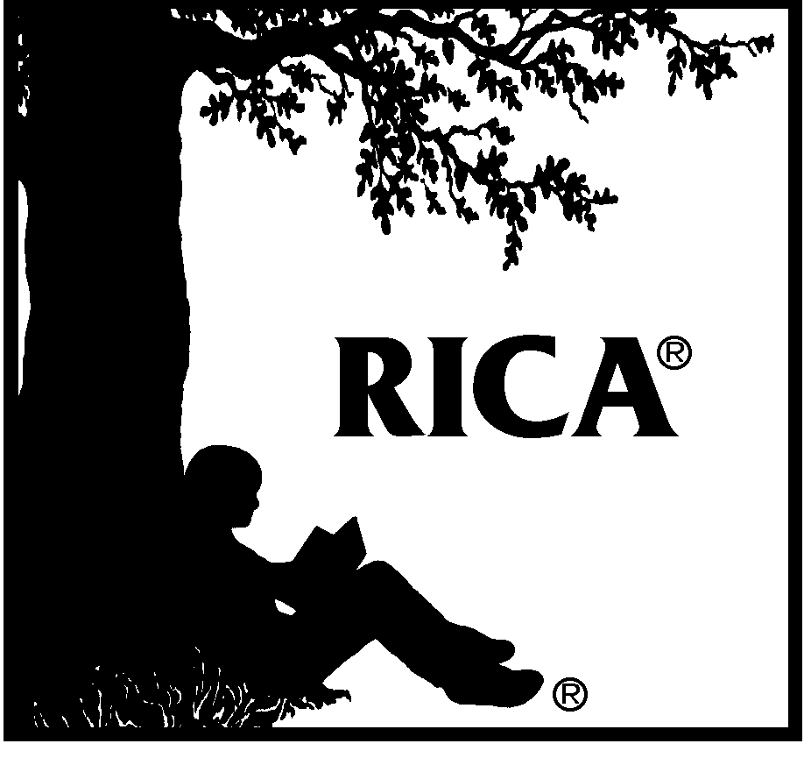

Reading Instruction Competence Assessment® 2023–2024

Setting 3, Part B: Individual Instruction Template
The Setting 3: Individual Instruction Video and Template should demonstrate the following:
- instruction of an individual student
- your ability to
- plan, organize, and manage reading instruction based on ongoing assessment, as described in Domain 1 of the RICA Content Specifications, and
- plan and deliver to an individual student an effective lesson that develops the student's vocabulary, academic language, and background knowledge
- the central instructional objective of the lesson derived from Competency 11 of Domain 4 of the RICA Content Specifications; you must demonstrate knowledge and skills in this competency
This template contains the Instructional Context Form and the Reflection Form for Setting 3: Individual Instruction.
Once completed, upload the template to the Pearson ePortfolio System and submit with Part A: Individual Instruction Video.
For more information about the RICA Video Performance Assessment Requirements, preparing your materials for submission, scoring of your submission, and the RICA Content Specifications, refer to the RICA® Video Performance Assessment Guide.

Individual Instructional Context Form
Complete this form by typing responses in 12-point Arial font within the brackets provided below each prompt, avoiding abbreviations and acronyms.
Provide complete responses to all applicable questions. Do not refer to a response that you have provided on a form in another template, because scorers will not have access to the other templates you have completed. Respond to the questions in relation to the entire lesson, even if you record only a segment of the lesson.

Section One: Lesson Plan
In this section, provide the details of your lesson plan.
- The lesson's central instructional objective must be derived from a single, specified competency in the specified domain of the RICA Content Specifications.
Indicate the Domain 4 competency from which your lesson's central instructional objective has been derived (type an "X" in the brackets next to the appropriate competency below):
[ ] Competency 11
- State the lesson's central instructional objective in behavioral terms. The objective should clearly state what the student (not the teacher) will be able to do as a result of the lesson.
[ ]
- Describe the instructional materials that you plan to use in your lesson.
[ ]
- Describe the lesson procedures, step by step. Number each step. Describe the entire lesson, even if you plan to record only a segment of the lesson. If only a segment of the lesson will be recorded, indicate which steps in the lesson will be included, in whole or in part, in the recorded segment by underlining the numbers of those steps.
[ ]
- Describe your plans for assessing the extent to which the student has achieved the lesson's central instructional objective. For example, how will you determine whether or not the student has achieved your central instructional objective?
[ ]

Section Two: Assessment and Planning
In this section, describe how you used assessment, prior to planning the lesson, to determine that the student would benefit from the lesson, and summarize previous lessons and/or instructional activities related to the planned lesson's central instructional objective.
- Describe your use of assessment to determine the student's need for the planned lesson. Your response should demonstrate knowledge and skills in competencies associated with Domain 1 of the RICA Content Specifications. On the left side of the chart, describe the specific assessment methods (formal and/or informal) you used. On the right side of the chart, for each assessment method, identify the information you gained about student strengths and needs in relation to the planned lesson's central instructional objective. If the lesson will be delivered to an English learner (i.e., a student whose primary language is other than English), be sure to include assessment methods you used with the student and the results.
Assessment Method | Student Strengths and Needs
[ ] | [ ]
[ ] | [ ]
[ ] | [ ]
Add more rows if needed.
- To help scorers understand the context in which your planned lesson will be delivered, summarize previous lessons and/or learning opportunities, if any, that the student has received related to the planned lesson's central instructional objective.
[ ]

Section Three: Student Information
In this section, provide information about the student to whom the lesson will be delivered.
- Indicate the grade level of the student for whom the lesson is planned. This item refers to the grade the student is in (e.g., first grade, sixth grade), not to the student's reading grade level.
[ ]
- Indicate the student's primary language. If English, respond to Items 3 and 6, and skip Items 4 and 5. If other than English (i.e., if the student is an English learner), skip Item 3, and respond to Items 4, 5, and 6.
[ ]
- If the student's primary language is English, summarize the student's English reading development.
[ ]
- If the student is an English learner, describe the extent to which the student can read in the student's primary language.
[ ]
- If the student is an English learner, summarize the student's English language proficiency, including the student's English reading development.
[ ]
- Describe other student background factors (e.g., cultural background, achievement differences, student with an Individualized Education Program or 504 plan) that affected the planning of your lesson, and describe how these factors affected your planning.
[ ]

Section Four: Instructional Materials Submission
OPTIONAL
If your lesson involves the use of instructional materials that may be difficult for scorers to see as they view your video recording and/or that will help scorers understand your video-recorded instruction (e.g., reading excerpt, student worksheet, handout, student work product), you may include those materials at the end of this template file. To be considered by scorers, the materials you submit must be scans of materials that are used during the video-recorded instruction. Label the instructional materials before scanning. Do not submit materials that identify your school or that include your or the student's first and last names. Be sure to request permission from family/guardians if you are submitting any student work. Please note that submitted materials will not be returned.
Type an "X" in the brackets next to the statement that applies to your submission:
[ ] I am including additional materials at the end of this template file.
[ ] I am not including additional materials at the end of this template file.
If you submit materials, please provide information as indicated in the brackets below each prompt.
- Type of material:
[ ]
Role in the lesson:
[ ]
- Type of material:
[ ]
Role in the lesson:
[ ]

Individual Reflection Form
After teaching the planned lesson and reviewing your video-recorded instruction, complete this form by typing responses in 12-point Arial font within the brackets provided below each prompt, avoiding abbreviations and acronyms.
Provide complete responses to all applicable questions. Do not refer to a response that you have provided on a form in another template, because scorers will not have access to the other templates you have completed. Respond to the questions in relation to the entire lesson, even if you recorded only a segment of the lesson.
- During the delivery of the planned lesson, did you make any modifications to the lesson in response to the student's reading strengths, needs, or other factors? (Type an "X" in the brackets next to the appropriate answer below.)
[ ] Yes [ ] No
Describe modifications, if any, you made to your planned lesson (as you were delivering it) due to student reading strengths, needs, or other factors. Be specific and refer to the lesson plan you provided on the Instructional Context Form. For each modification, explain why you decided to make the change, referring whenever possible to student responses and/or behavior.
[ ]
- Evaluate the extent to which the student achieved the lesson's central instructional objective. Refer to Section One, Item 5 on the Instructional Context Form, and cite specific student responses or behaviors or other assessment results that support your evaluation.
[ ]
- Reflect on how the lesson might be improved. Refer to the lesson plan you provided on the Instructional Context Form and identify at least one aspect of the lesson that could be modified to address the same central instructional objective more effectively in the future.
[ ]
- Describe how you will use assessment information you obtained from the lesson to plan future instruction. For example, how will you use the assessment information obtained as a result of the lesson to plan future instruction for this student to build upon or extend their development as a reader? Your response should demonstrate knowledge and skills in competencies associated with Domain 1 of the RICA Content Specifications.
[ ]
- Provide any other information (other than the information you have already provided on the Instructional Context Form and this form) about your lesson that would help scorers understand and evaluate your video-recorded instruction and template responses.
[ ]

